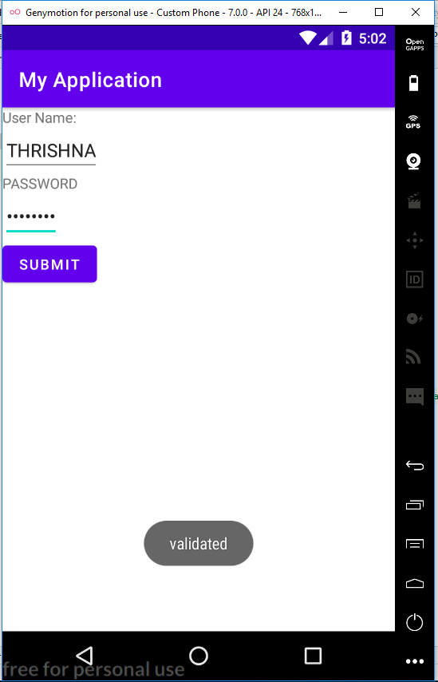

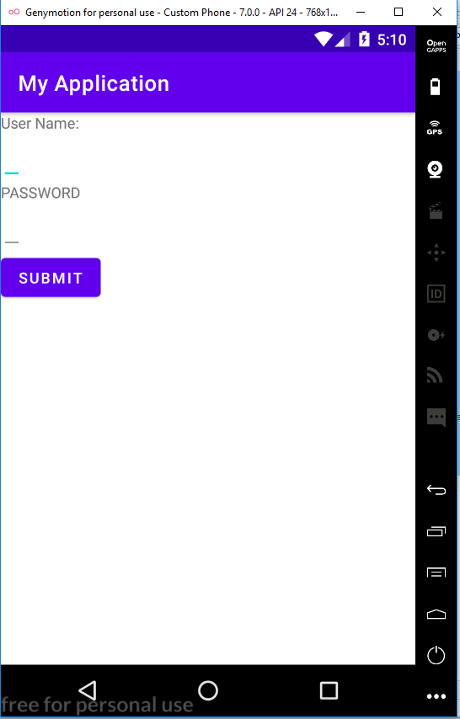

MAIN_ACTIVITY.JAVA

package com.example.myapplication;  
  
import androidx.appcompat.app.AppCompatActivity;  
  
import android.os.Bundle;  
import android.view.View;  
import android.widget.Button;  
import android.widget.Toast;  
  
public class MainActivity extends AppCompatActivity {  
 Button b;  
  
 @Override  
 protected void onCreate(Bundle savedInstanceState) {  
 super.onCreate(savedInstanceState);  
 setContentView(R.layout.*activity_main*);  
 b=findViewById(R.id.*b*);  
 b.setOnClickListener(new View.OnClickListener() {  
 @Override  
 public void onClick(View view) {  
 Toast.*makeText*(getApplicationContext(), "validated", Toast.*LENGTH_SHORT*).show();  
 }  
 });  
 }  
}

**ACTIVITY_MAIN.XML**

*<?*xml version="1.0" encoding="utf-8"*?>*<LinearLayout xmlns:android="http://schemas.android.com/apk/res/android"  
 xmlns:app="http://schemas.android.com/apk/res-auto"  
 xmlns:tools="http://schemas.android.com/tools"  
 android:layout_width="match_parent"  
 android:layout_height="match_parent"  
 android:orientation="vertical"  
 tools:context=".MainActivity">  
  
 <TextView  
 android:layout_width="wrap_content"  
 android:layout_height="wrap_content"  
 android:text="User Name:"/>  
  
 <EditText  
 android:layout_width="wrap_content"  
 android:layout_height="wrap_content"/>  
  
 <TextView  
 android:layout_width="wrap_content"  
 android:layout_height="wrap_content"  
 android:text="PASSWORD"/>  
  
 <EditText  
 android:layout_width="wrap_content"  
 android:layout_height="wrap_content"  
 android:inputType="textPassword"/>  
 <Button  
 android:layout_width="wrap_content"  
 android:layout_height="wrap_content"  
 android:text="SUBMIT"  
 android:id="@+id/b"/>  
  
</LinearLayout>